**CS3431-A22 Project Phase 1 Solutions**

**ERD**

Assumption: Employees, patients and medical equipment can leave the hospital, in which case, their location becomes null.

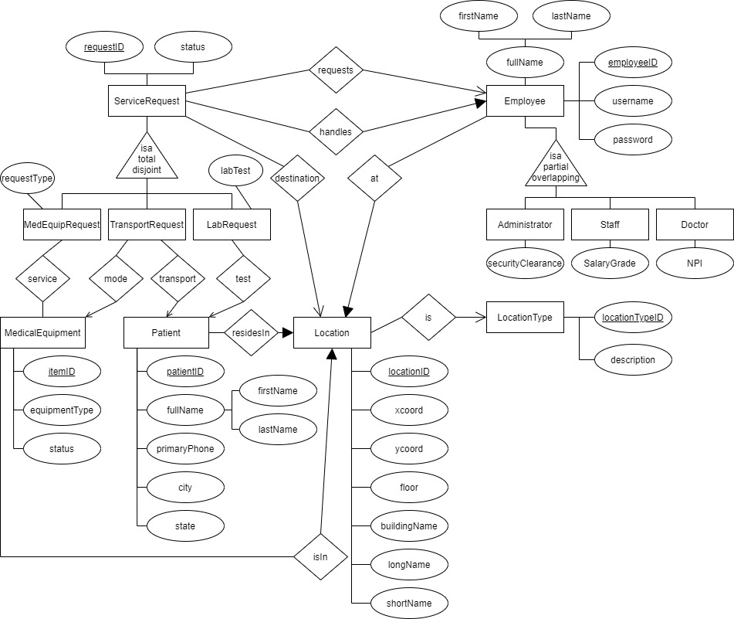

**Relational Schema**

LocationType (locationTypeID PK, description)

Location (locationID PK, xcoord, ycoord, floor, buildingName, longName, shortName, locationTypeID FK)

Employee (employeeID PK, username, password, firstName, lastName, securityClearance, salaryGrade, NPI, locationID FK)

Patient (patientID PK, firstName, lastName, primaryPhone, city, state, locationID FK)

MedicalEquipment (itemID PK, equipmentType, status, locationID FK)

ServiceRequest (requestID PK UQ, role UQ, status, requesterEmployeeID FK, handlerEmployeeID, destinationID FK)

MedicalEquipmentRequest (requestID PK FK, role FK, requestType)

Service(requestID PK FK, itemID PK FK)

TransportRequest (requestID PK FK, role FK, itemID FK, patientID FK)

LabRequest (labRequestID PK FK, role FK, labTest, patientID FK)